CLIENT INTAKE & RELEASE OF LIABILITY FORM

Date of first session:

Name:
Address: ________________________________________________________________________
________________________________________________________________________
Phone: ________________________________________________________________________
Email: ________________________________________________________________________
Date of Birth: ____________________________________________________________________

Emergency Contact: ___________________________________

Virtual Session Preference: Zoom FaceTime Skype Phone

How did you hear about me?

Briefly list major accidents, surgeries, traumas, current chronic health conditions.
Date Description

Reason for today’s shamanic healing session:

____________________________________________________________________________________________________________________________________

Are you currently taking any medications? If so, please list.

_____________________________________________________________________________________________________________________________________

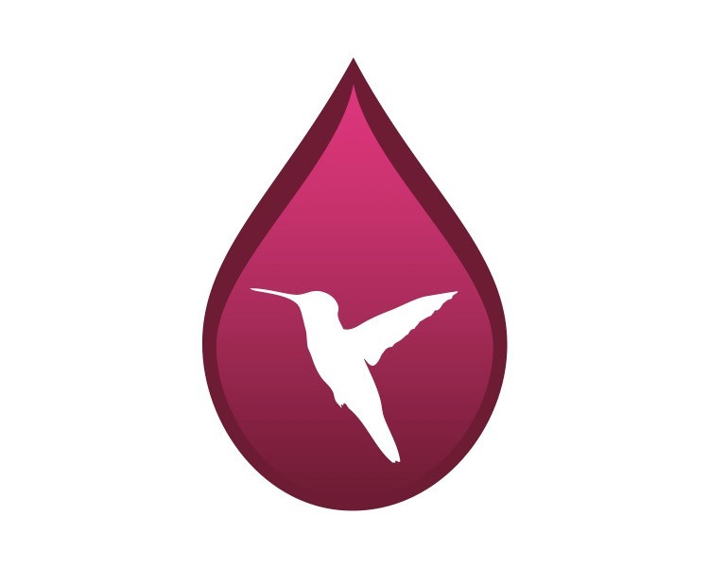
I understand that I will be participating in a shamanic healing session. This is not a medical treatment nor is there any promise of a cure. I agree to hold my practitioner, Mikki Baloy, and Birdsong Healing harmless for any reactions resulting from this treatment (or series of treatments). Understanding the above, I give my permission for treatment.

Signature Date

